**Natural Resources Canada**

**Emergency Geomatics Service (EGS)**

**– River Ice Breakup Classification Tool – Installation Instructions**

**For: Ontario Ministry of Natural Resources and Forestry**

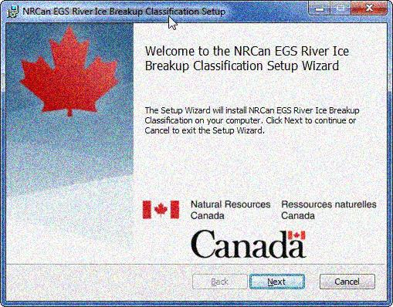

**Release 1.0**

**October 19, 2016**

Table of Contents

0 Document Revision History 3

1 Introduction 4

2 Dependencies 5

3 Run EGS_RiverIceBreakupClassification.msi 7

3.1 UNZIP basedata Files 12

3.1.1 dem Subdirectory 12

3.1.2 watermask Subdirectory 13

4 Customizing The Tool 15

4.1 SQLite Database 15

4.1.1 Adjust Application Parameters 15

4.1.2 AOIs, Paths and Names Of DEMs and Water Masks 16

4.1.3 Month and Prov tables 18

4.2 Map Template 19

5 Workspace Naming Convention 21

6 RIBC Installation Test 23

6.1 Retrieve Test Image 23

6.2 Launch RIBC Tool 27

6.3 Generate Ice Classification Product 29

6.4 Generate Distribution Package 31

6.5 Results 34

6.5.1 Directory Contents 34

6.5.2 Ice Classification TIF File 35

6.5.3 KMZ File 36

6.5.4 Map 37

7 Appendix A: Database Administration – Firefox SQLite Manger Add-on 38

7.1 Installing Firefox SQLite Manager 38

7.2 Examine Database Tables 38

# Document Revision History

|  |  |  |  |
| --- | --- | --- | --- |
| Version | Date | Author | Description |
| 1.0 | October 19, 2016 | Victor Neufeld | Original |

# Introduction

This document contains instructions on how to install and configure the River Ice Breakup Classification tool developed and owned by the Emergency Geomatics Service (EGS) branch of Natural Resources Canada. The tool consists of proprietary executables, Python libraries, an SQLite database and image files, and relies on commercial products such as PCI Geomatica, ESRI ArcGIS and GlobalMapper to do its work.

The tool and instructions have been customized, where required, for the intended recipient, Ontario Ministry of Natural Resources and Forestry.

# Dependencies

The following commercial and OpenSource components are required for successful operations of the River Ice Breakup Installation tool. Ensure these are present prior to installing RIBC.

* Python 2.7
  + Path should be that defined by ArcGIS installation for both 32-bit and 64-bit libraries; ie.

**C:\Python27\ArcGIS10.x**

**C:\Python27\ArcGISx6410.x**

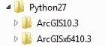

* ArcGIS Desktop 10.3.1 (preferred, or higher, however 10.2 should work)
* ArcGIS 64-Bit Background Geoprocessing Python libraries
* lxml Python library
  + Used for XML parsing, not part of the standard Python installation. Can be installed manually or by using Python **pip** package manager.
  + Manual installation:
    - Obtain Windows installer **lxml-3.6.0.win32-py2.7.exe** (32-bit), **lxml-3.6.0.win-amd64-py2.7.exe** (64-bit) at <https://pypi.python.org/pypi/lxml/3.6.0>
    - Installer will create Python library such as

**C:\Python27\ArcGIS10.3\Lib\site-packages\lxml**

* + **pip** installation:
    - Download pip at <https://bootstrap.pypa.io/get-pip.py>
    - Install pip; eg.:

**C:\Python27\ArcGIS10.3\python.exe get-pip.py**

Download lxml Windows binaries **lxml-3.6.4-cp27-cp27m-win32.whl**

at <http://www.lfd.uci.edu/~gohlke/pythonlibs/#lxml>

* + - Install lxml using pip:

**C:\Python27\ArcGIS10.3\python.exe -m pip install lxml-3.6.1-cp27-cp27m-win32.whl**

* PCI Geomatica 2015 **\***
  + **\*** May work with other versions of Geomatica. Will require alteration of **PCI_GEOMATICA_FOCUS** path defined in **app_params_riverice** SQLite database table, described in a later section of this document.
* Global Mapper v16 (64 bit)
* After running the RIBC installer, the following Environment Variable changes should be present (accessed through :

***Control Panel->System->Advanced System Settings->Advanced tab->Environment Variables***)

* + **Path** should contain:
    - **C:\PCI Geomatics\Geomatica 2015\exe** [or whatever version of PCI is being used]
    - **C:\Python27**
  + **Python27** = **C:\Python27\ArcGIS10.3\Python.exe**
  + **Python27_x64** = **C:\Python27\ArcGISx6410.3\Python.exe**
  + **GlobalMapper** = **C:\Program Files\GlobalMapper16_64bit\global_mapper.exe**
  + **PYTHONPATH** = **C:\PCI Geomatics\Geomatica 2015\exe** [or whatever version of PCI is being used]

# Run EGS_RiverIceBreakupClassification.msi

The **EGS_RiverIceBreakupClassification.msi** will be used to install and deploy the components and environment settings that the River Ice Breakup Classification tool employs. Double-click on the file and follow the instructions provided through the Setup Wizard. Please note, while the ***Destination Folder*** window of the wizard provides an opportunity to change the default installation folder, **DO NOT** change it from **C:\EGS\**. Several components expect their supporting files to be located below this root directory and the application will fail if they are not there.

The first window displayed will be as follows:

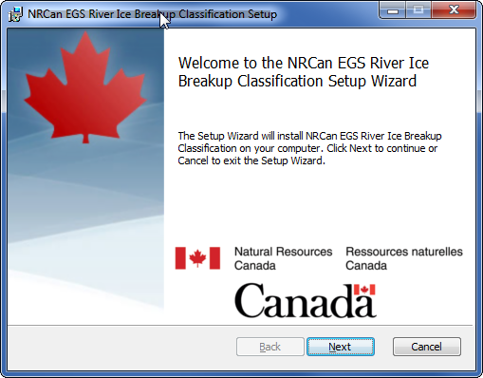

The next window will display the license agreement that has been prepared and signed by NRCan and OMNR. Accept the terms and continue.

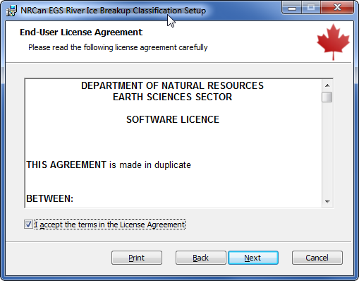

The window that follows is used to define the Destination Folder. As mentioned, accept the **C:\EGS\** value.

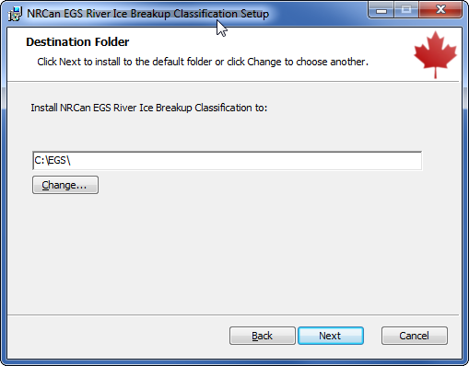

Next, press the **Install** button to begin deployment. You must have **System Administrator** privileges and will be prompted for an authorized account and password if you do not.

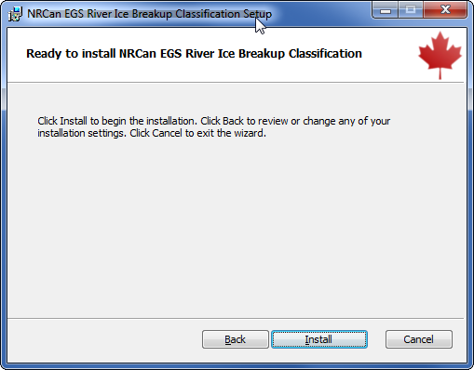

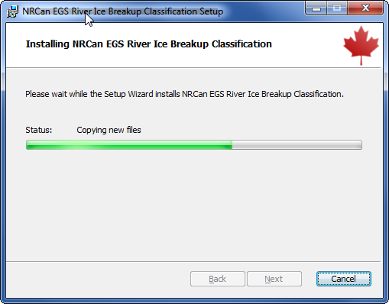

Finally, press the **Finish** button. The contents of the **C:\EGS** directory will be as shown on the next page.

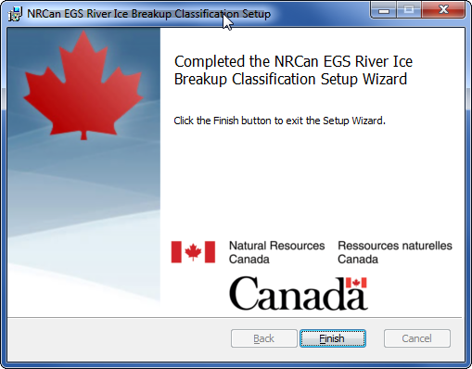

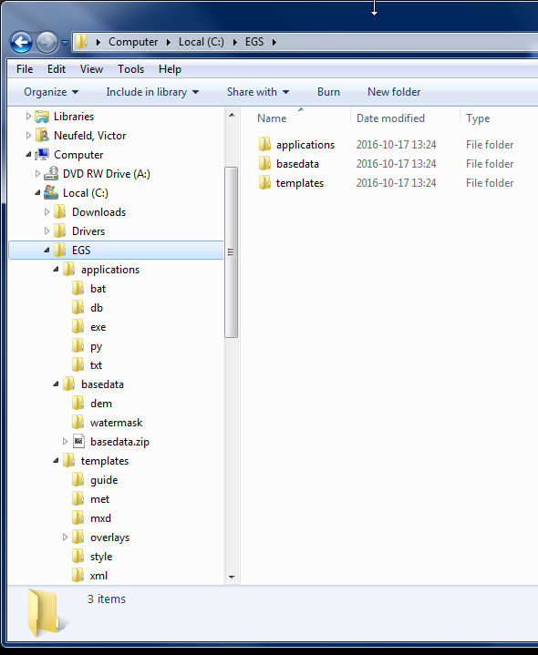

## UNZIP basedata Files

The package includes the DEMs and Water Masks that NRCan has used for northern Ontario communities located off the James Bay coast for the 2016 ice monitoring season. They are in the Lambert Conic Conformal projection that NRCan generally employs with maps (PCI Geomatica code “**CanLCC E008**”). The files can be used as-is, or serve as a starting point for OMNR until it prepares its own files. They are large and have been distributed in ZIP file **C:\EGS\basedata\basedata.zip** that must be manually unpacked before the tool can be used.

The target directories for the files are:

**C:\EGS\basedata\dem**

**C:\EGS\basedata\watermask**

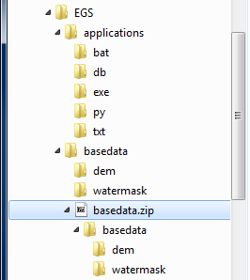

### dem Subdirectory

The **dem** subdirectory will initially contain a **README.txt** file that lists the following instructions:

**The following files must be manually placed in this directory:**

**- N_Ontario_DEM_UTM16_to__E008.tif**

**- N_Ontario_DEM_UTM16_to__E008.tif.pox**

**- N_Ontario_DEM_UTM17_to__E008.tif**

**- N_Ontario_DEM_UTM16_to__E008.tif.pox**

**Files can be found in "C:\EGS\basedata\basedata.zip".**

Copy the above files from **basedata.zip** to the **dem** subdirectory.

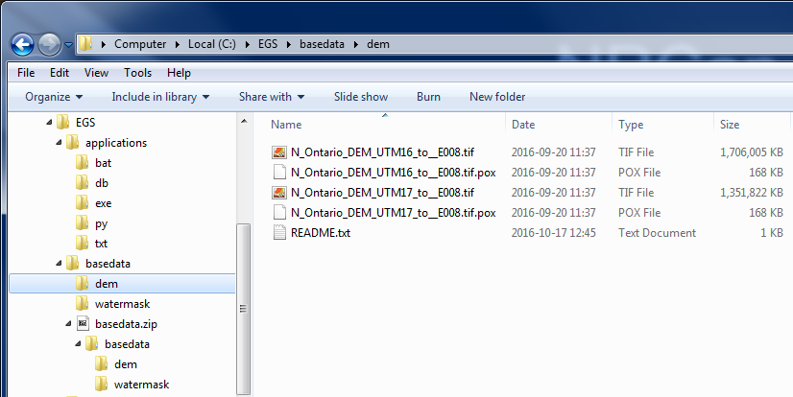

### watermask Subdirectory

The **watermask** subdirectory will initially contain a **README.txt** file that lists the following instructions:

**The following files must be manually placed in this directory:**

**- Albany_and_forks_watermask_E008.tif**

**- Albany_and_forks_watermask_E008.tif.pox**

**- Attawapiskat_and_forks_watermask_E008.tif**

**- Attawapiskat_and_forks_watermask_E008.tif.pox**

**- Moose_Watermask_E008.tif**

**- Moose_Watermask_E008.tif.pox**

**- Severn_winisk_watermask_E008.tif**

**- Severn_winisk_watermask_E008.tif.pox**

**Files can be found in "C:\EGS\basedata\basedata.zip".**

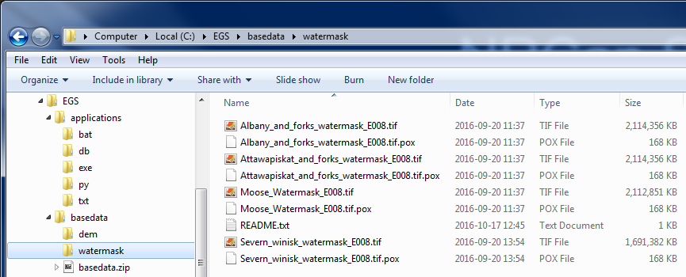

The tool should now be ready for use.

**NOTE:**

If the files are not unpacked as described, will get the error shown below when trying to run the tool.

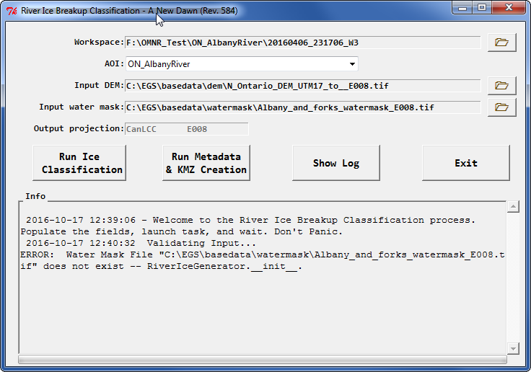

# Customizing The Tool

## SQLite Database

The River Ice Breakup Classification tool employs an SQLite database for several of the settings and parameters it uses. This database will be found at **C:\EGS\applications\db\egs_db.db**. If you do not already have an application capable of managing SQLite databases, a Firefox web-browser add-on is available for free. Installation and use of the **SQLite Manager** add-on is described in **Appendix A**.

### Adjust Application Parameters

The **app_parameters_riverice** table contains a series of parameters that define the locations of various files used by the tool. For the most part, these should not be changed. The exception may be for the **PCI_GEOMATICA_FOCUS** parameter. If PCI Geomatica is not installed at the location shown, or if you are running an older or newer version of Geomatica, then the **param_value** for that record should be changed accordingly.

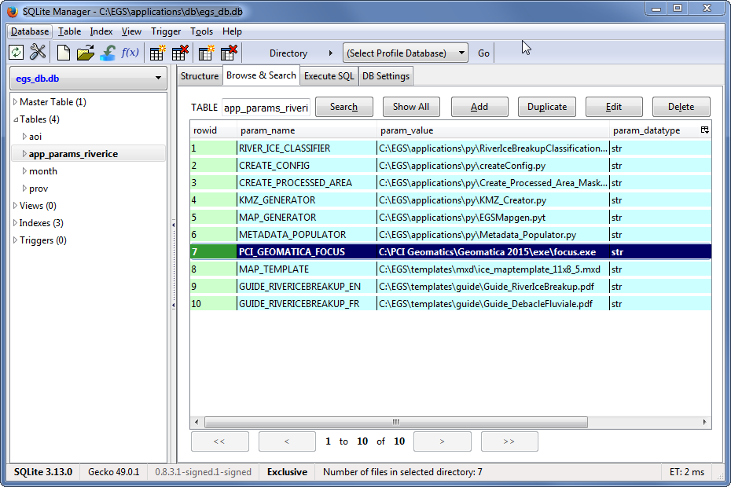

### AOIs, Paths and Names Of DEMs and Water Masks

The **aoi** table contains information about every Area Of Interest (**AOI**) that the tool may be applied to. NRCan has defined 8 different AOIs for the region west of James Bay. The data found in the table is as follows:

* **aoi_code**

A unique identifier for an AOI whose format is ***PROVINCECODE_AREANAME***. All OMNR records are expected to have a PROVINCECODE component of **ON**. The AREANAME typically identifies the body of water, drainage basin or community being monitored.

* **prov_code**

Province code, expected to be **ON** for all OMNR records.

* **aoi_en**

English name of the AOI.

* **aoi_fr**

French name of the AOI.

* **river_en**

English name of the body of water being monitored. This will often be similar or the same as the **aoi_en** value, but not always. For example, NRCan maintains a New Brunswick **aoi_en** value of **NB_Fredericton** that corresponds to **river_en** value **Saint John River**.

* **aoi_fr**

French name of the body of water being monitored.

* **proj**

The PCI Geomatica projection code that has been incorporated in the DEM and Water Mask. NRCan currently uses a code of “**CanLCC E008**” to match the Canada Lambert Conformal Conic value commonly used in its base maps. Other codes that have been used in the past for the James Bay region are “**UTM 16 D122**” and “**UTM 17 D122**”.

* **dem_path**

Path and name of the default DEM used to orthorectify the RADARSAT-2 images for a given AOI and projection. At installation time, the files provided will be located in the **C:\EGS\basedata\dem** directory, but they can be moved to a new location or given a new name. If that is done, the corresponding **dem_path** values must be changed. Note that these are defaults – it is always possible to select an alternate file at run time.

* **water_mask_path**

Path and name of the default Water Mask used to orthorectify the RADARSAT-2 images for a given AOI and projection. At installation time, the files provided will be located in the **C:\EGS\basedata\watermask** directory, but they can be moved to a new location or given a new name. If that is done, the corresponding **water_mask_path** values must be changed. Note that these are defaults – it is always possible to select an alternate file at run time.

The table and map on the next page show the 8 AOIs that have been defined and rough outlines of the regions they encompass. Satellite imagery captured with those regions would be assigned to the associated AOIs.

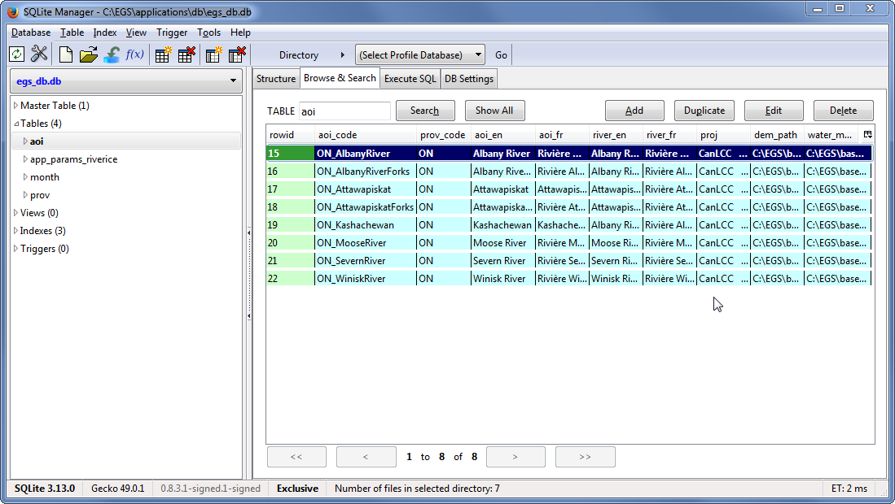

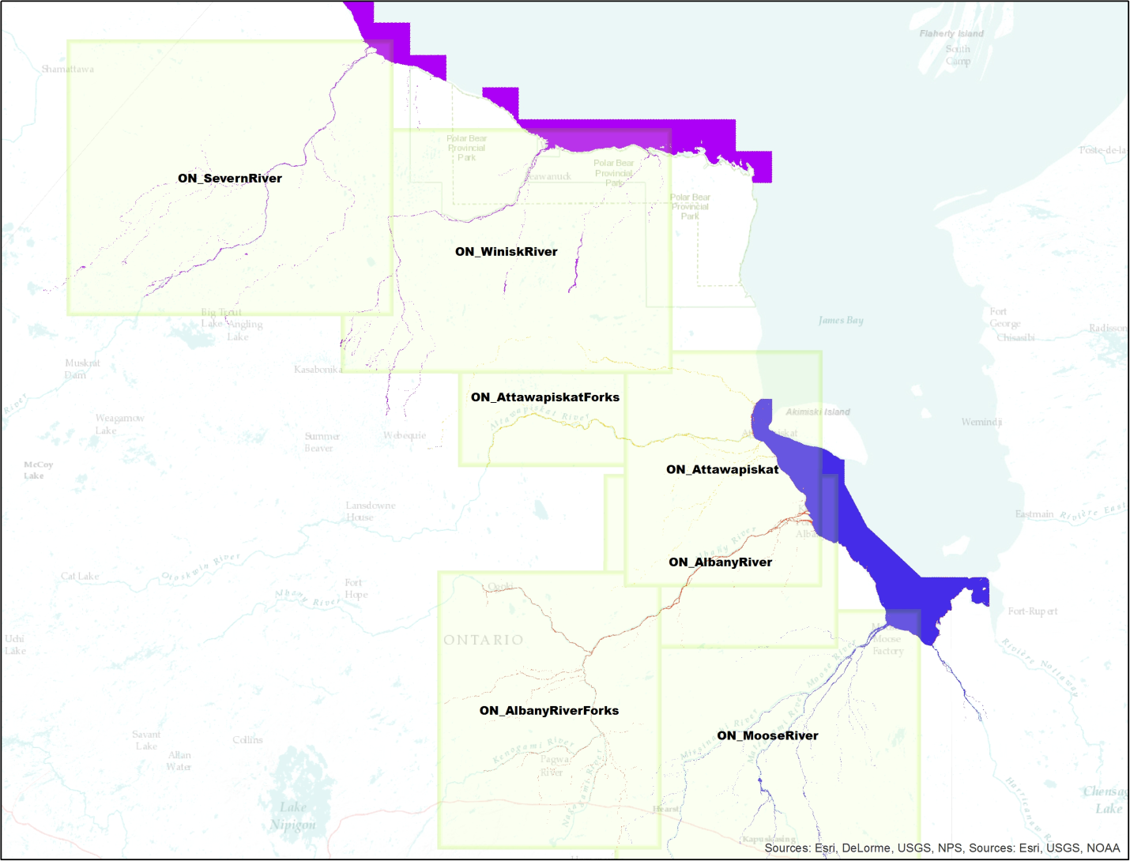

It is possible to make changes to the contents of the **aoi** table to customize the operations of the RIBC tool. Some of the changes that might be considered are:

* Move the DEM and Water Mask base data from the **C:\EGS\basedata** directory to some other location. If that is done, the **dem_path** and **water_mask_path** fields of the affected records would have to be changed accordingly.
* If alternate DEMs and Water Masks are to be introduced, it may be necessary to change the file names of the affected records in the **dem_path** and **water_mask_path** fields. Furthermore, if those files incorporate a different projection, the **proj** field content would have to be changed accordingly.
* OMNR may wish to introduce new areas that it will monitor. In that situation, new associated **aoi** records will need to be created. When doing so, must use the format ***PROVINCECODE_AREANAME*** for the **aoi_code** field. The application expects only one underscore within the entire string, used during parsing, so the ***AREANAME*** component cannot contain underscores (NRCan employs camel-case to distinguish elements within ***AREANAME***).

### Month and Prov tables

The **month** and **prov** tables are code tables that provide English and French translations for month and province codes. Do not change these.

## Map Template

The distribution package produced by the RIBC tool in the **results** folder includes the ice classification TIF file, a metadata file, a KMZ file, and a map in both MXD and PDF formats. The map is generated from a standard template that a corresponding utility converts into a final product. Labels within the template contain tokens of format “**%TOKEN_NAME%**” that are replaced with data taken from the **aoi** table.

NRCan has created a template for OMNR that can serve as a starting point and can be customized, as required. After installation, the file will be located at:

**C:\EGS\templates\mxd\ice_maptemplate_11x8_5.mxd**

A screen capture of the template is shown below.

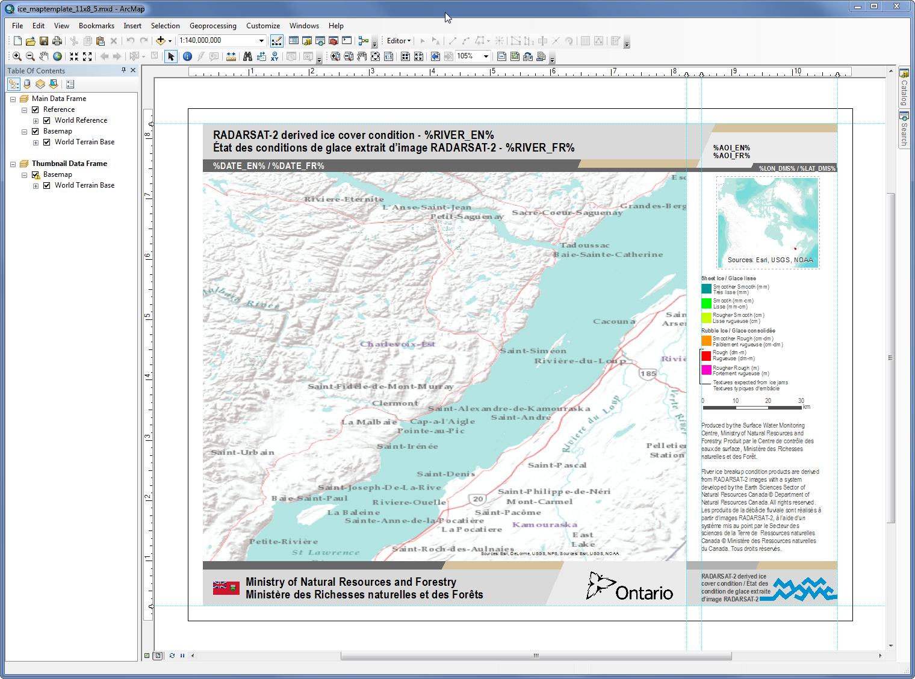

Some of the changes that might be considered are:

* NRCan base maps for the main and inset dataframes have been replaced with ESRI online maps. OMNR may wish to substitute those with its own base maps.
* NRCan-specific labels and Canada wordmarks have been replaced with OMNR and Province of Ontario equivalents. OMNR may wish to replace these.
* NRCan and RADARSAT-2 credits should be maintained.

The map below was produced with NRCan’s own template, and is provided for reference. By comparing to the template shown on the previous page, it is possible to determine which elements were replaced, and how the label tokens are substituted with derived and **aoi** table values.

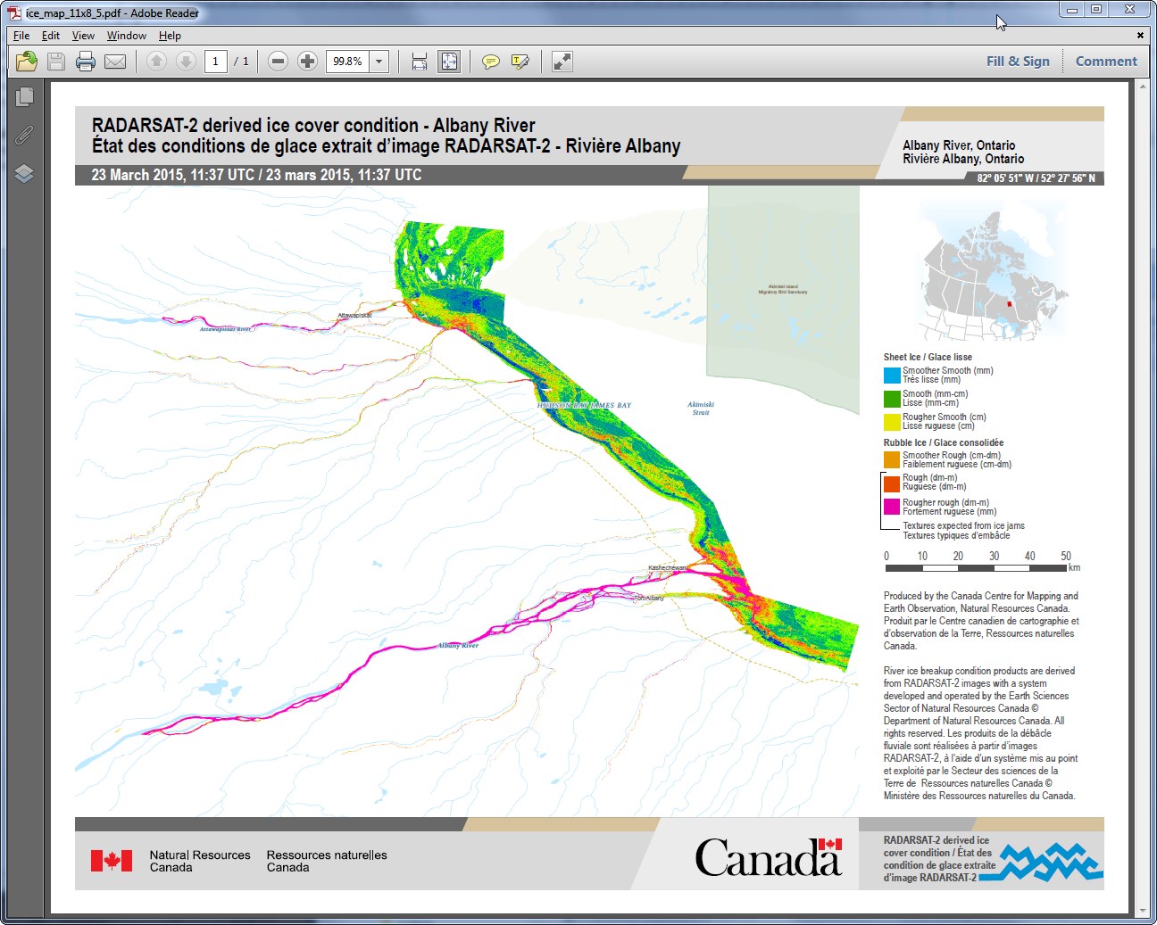

# Workspace Naming Convention

While not mandatory to employ, the RIBC tool has been designed to take advantage of a workspace naming convention used by NRCan to auto-complete several fields in the form. The general format of this convention is:

**RootDirectory\AOICode\YYYYMMDD_HHMMSS_BeamMode**

where:

**RootDirectory** = Drive/server and root directory below which RADARSAT-2 imagery is being collected. For example, may be organized for a given year in directory ***2017***.

**AOICode** = Area Of Interest code. All images for each AOI may be organized within its own common subdirectory.

**YYYYMMDD** = The datestamp for the image. When multiple images are to be mosaicked together, this may be the datestamp of the last (most recent) image.

**HHMMSS** = The timestamp for the image. When multiple images are to be mosaicked together, this may be the timestamp of the last (most recent) image.

**BeamMode** = The beam mode of the image(s).

Consider the following example that employs this convention.

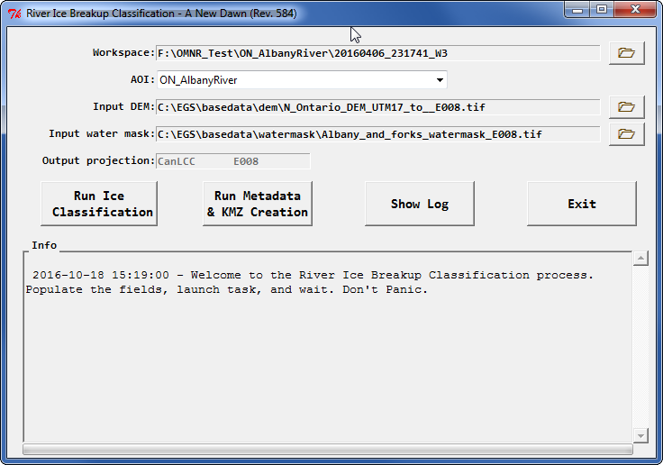

The tool is directed to workspace:

**F:\OMNR_Test\ON_AlbanyRiver\20160406_231741_W3**

within which it must find raw RADARSAT-2 ZIP file:

**RS2_OK73996_PK661982_DK590984_W3_20160406_231741_HH_HV_SGF.zip**

By specifying this directory, the tool will extract the AOI from the path and determine that it is **ON_AlbanyRiver**. Then it will automatically set the **AOI**, **Input DEM**, **Input water mask** and **Output projection** data entry fields to values it retrieves from the **aoi** database table. It is recommended to take advantage of this convenience by following the suggested naming convention.

# RIBC Installation Test

With the RIBC tool now installed, it is advisable to run a test to verify that it is functioning properly.

Due to copyright restrictions, NRCan cannot directly provide OMNR with a copy of a RADARSAT-2 image to test with, however OMNR may be able to retrieve the test image being used in this section on its own.

Specifications are as follows:

|  |  |  |  |
| --- | --- | --- | --- |
| **RADARSAT-2** | **2016-04-06 23:17:43** | **Wide 3** | **HH HV** |

## Retrieve Test Image

The image being used in this test is one that NRCan ordered while monitoring the Albany River region during the Spring of 2016:

**RS2_OK73996_PK661982_DK590984_W3_20160406_231741_HH_HV_SGF.zip**

An equivalent image can be retrieved from NRCan’s NEODEF catalogue through the following link:

<https://neodf.nrcan.gc.ca/neodf_cat3/>

The screen captures on the next three pages demonstrate this process and provide specifications that should allow OMNR to obtain the image to test with and compare results to those shown in this section .

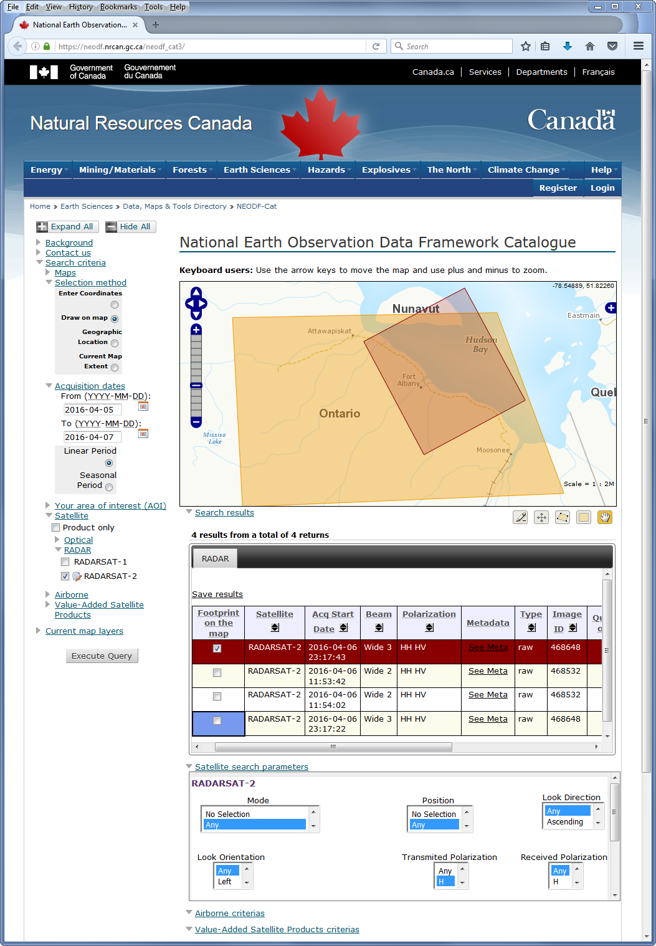

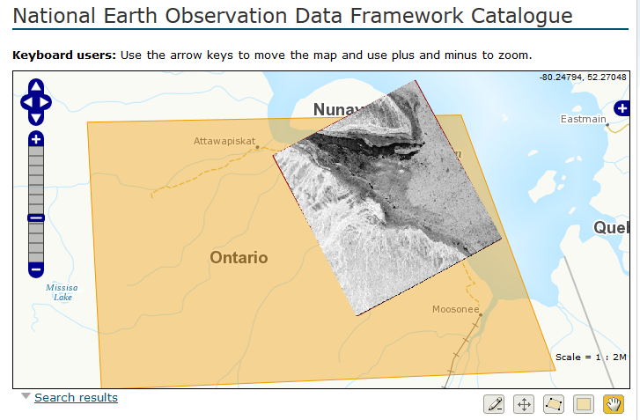

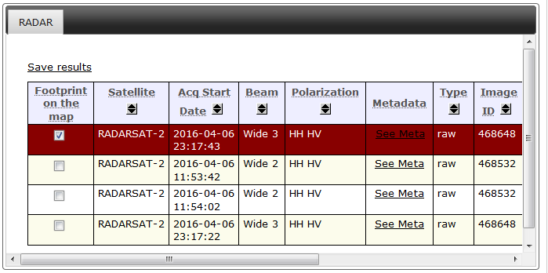

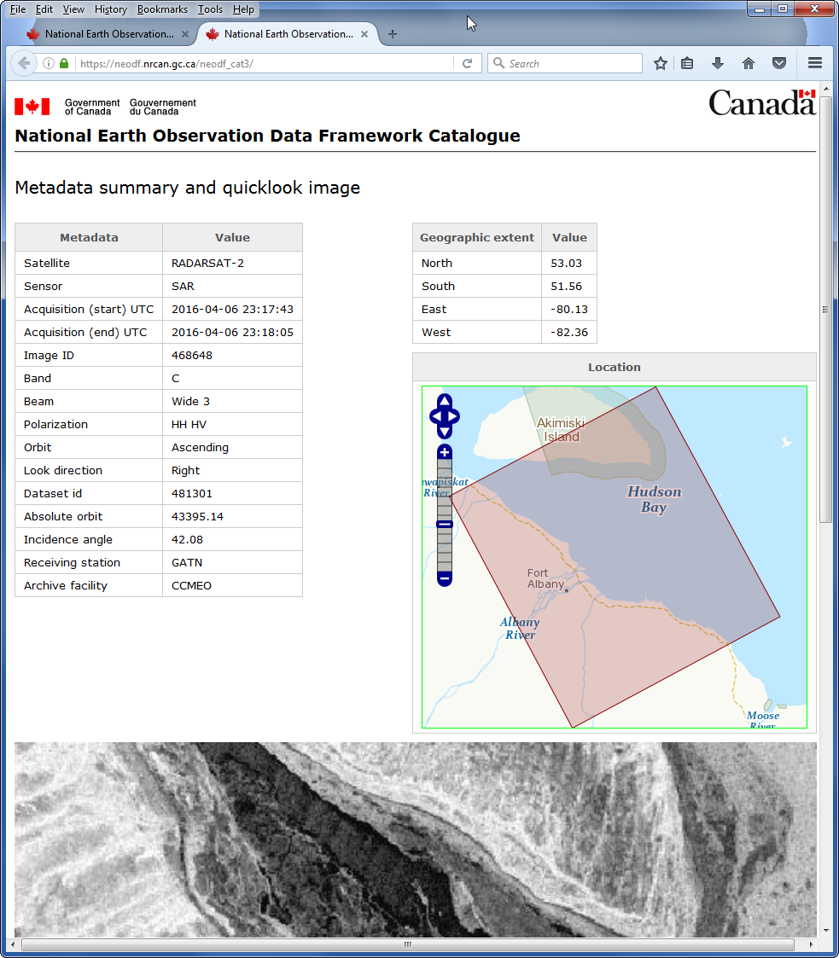

The equivalent ZIP file package is placed in directory that subscribes to the recommended NRCan naming convention:

**F:\OMNR_Test\ON_AlbanyRiver\20160406_231741_W3**

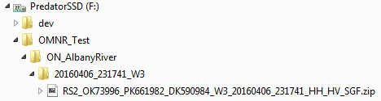

## Launch RIBC Tool

To launch the RIBC tool, double-click on batch file:

**C:\EGS\bat\RiverIce_Launcher.bat**

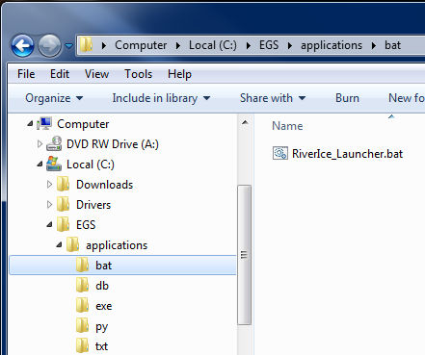

A Windows command terminal will open, followed briefly by a splash screen and finally the GUI itself. Set the **Workspace** field to the aforementioned directory. Since it follows the NRCan directory naming convention, default values will be automatically assigned to the remaining fields.

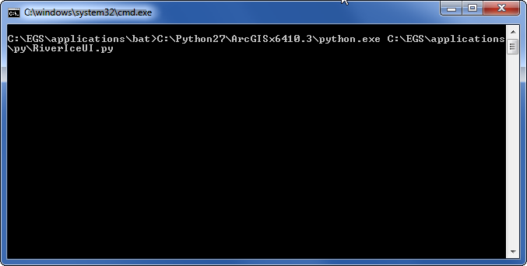

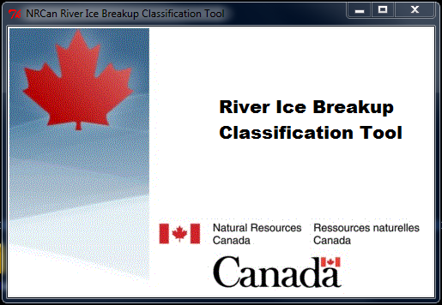



## Generate Ice Classification Product

Begin by clicking on the “**Run Ice Classification**” button. Its background will turn a pale green, it’s label will change to “**Classification in progress**”, log information will appear in the **Info** field, and the progress bar will gradually fill. Just prior to completing, the PCI Geomatic **Focus** window will open to permit you to inspect the results. This window **must** be manually closed before the script can continue. Close **Focus** and if all goes well, the button will turn bright green and its label will turn to “**Classification completed**” (if problems are encountered, the button will turn bright red). The first step is now complete.

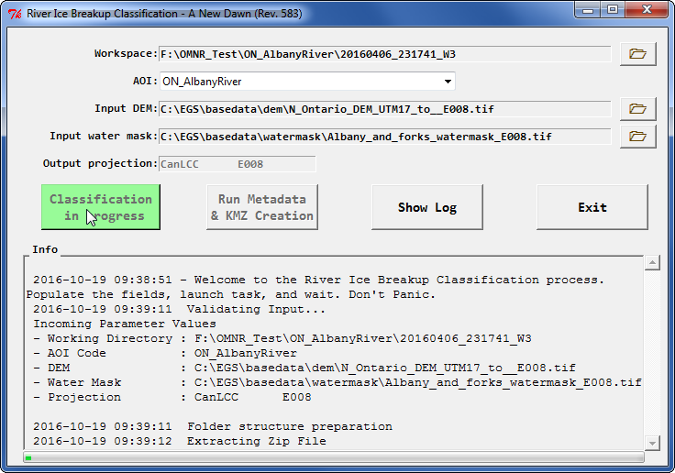

*Geomatica Focus pop-up. Must manually close before script will continue.*

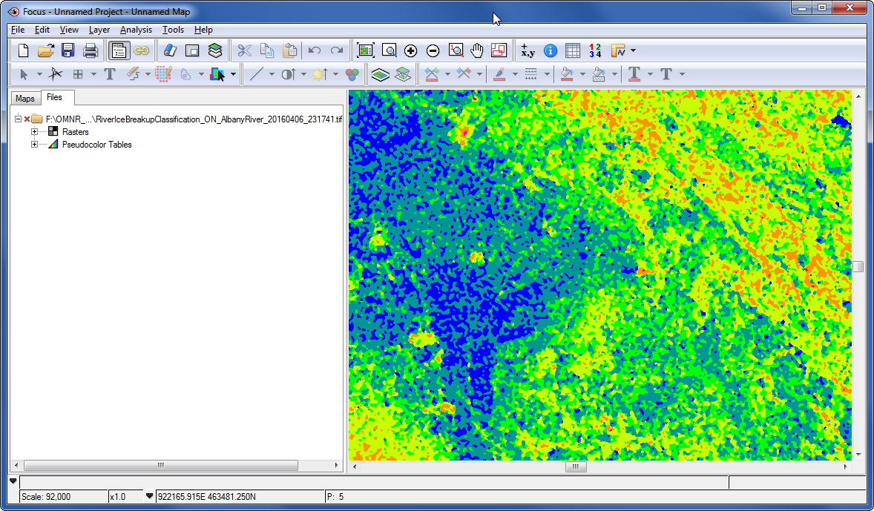

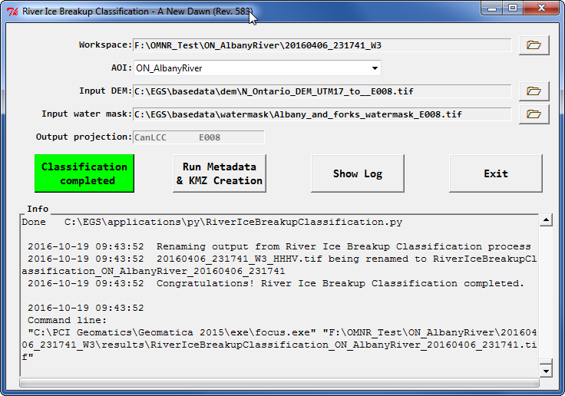

## Generate Distribution Package

Now click on the “**Run Metadata & KMZ Creation**” button. Its background will turn a pale green, it’s label will change to “**KMZ creation in progress**”, log information will appear in the **Info** field, and the progress bar will gradually fill. A number of items will be generated. During the course of operations, the **Global Mapper** window will open and transform the ice classification product into the initial version of the KMZ. During this step, the “**Exporting PNG**” pop-up will appear to stuck in an endless loop, with its progress bar cycling over and over. This is normal and will take some time to complete, but will eventually be closed automatically. A map will then be created. If all goes well, a ‘thumbs up’ will appear in the log window, the button will turn bright green and its label will turn to “**KMZ creation completed**” (if problems are encountered, the button will turn bright red). Packaging is now complete.

Examine the contents of the **Workspace** directory. Several files and two subdirectories will be present. The **raw** subdirectory will contain the RADARSAT-2 image in ZIP and unpacked format. The **results** folder will contain files to be distributed, packaged in ZIP file:

**RiverIceBreakupClassification_ON_AlbanyRiver_20160406_231741.zip**

The automatically-generated MXD can be opened to add additional annotations, if required.

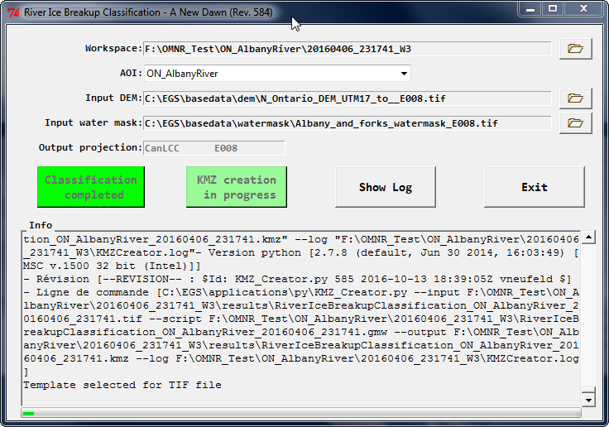

*Global Mapper, progress bar looks to be in endless loop but is not.*

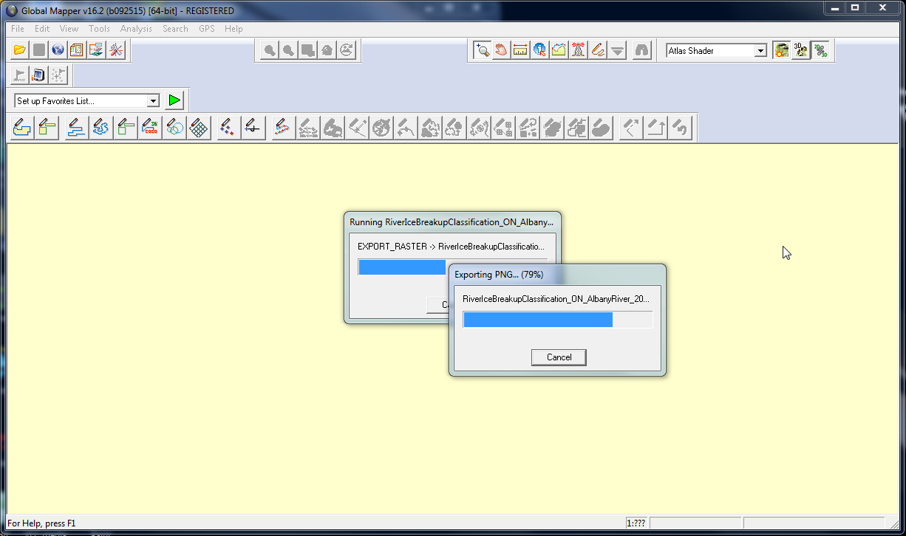

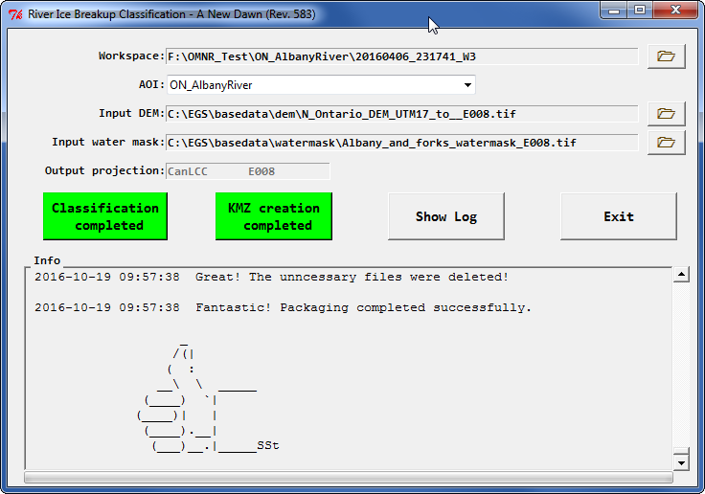

## Results

### Directory Contents

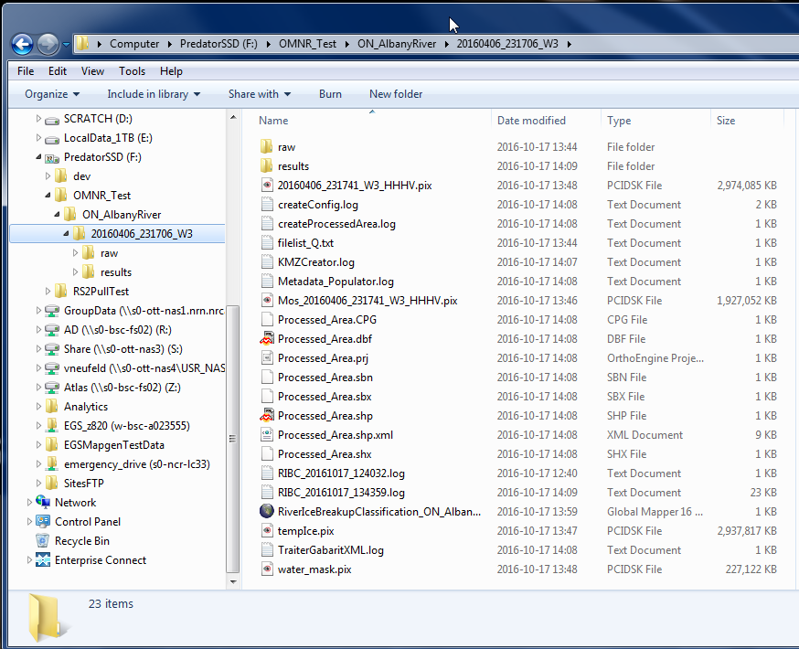

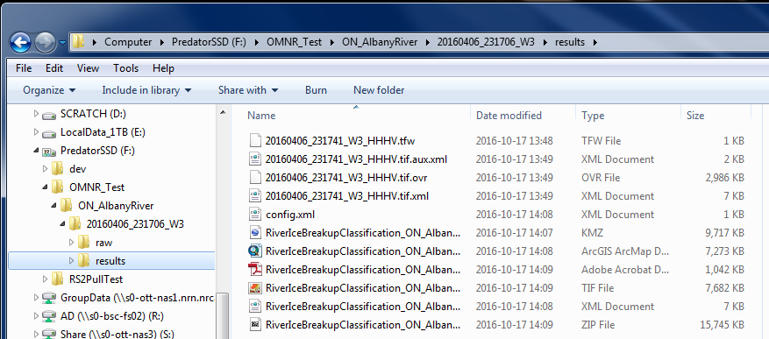

### Ice Classification TIF File

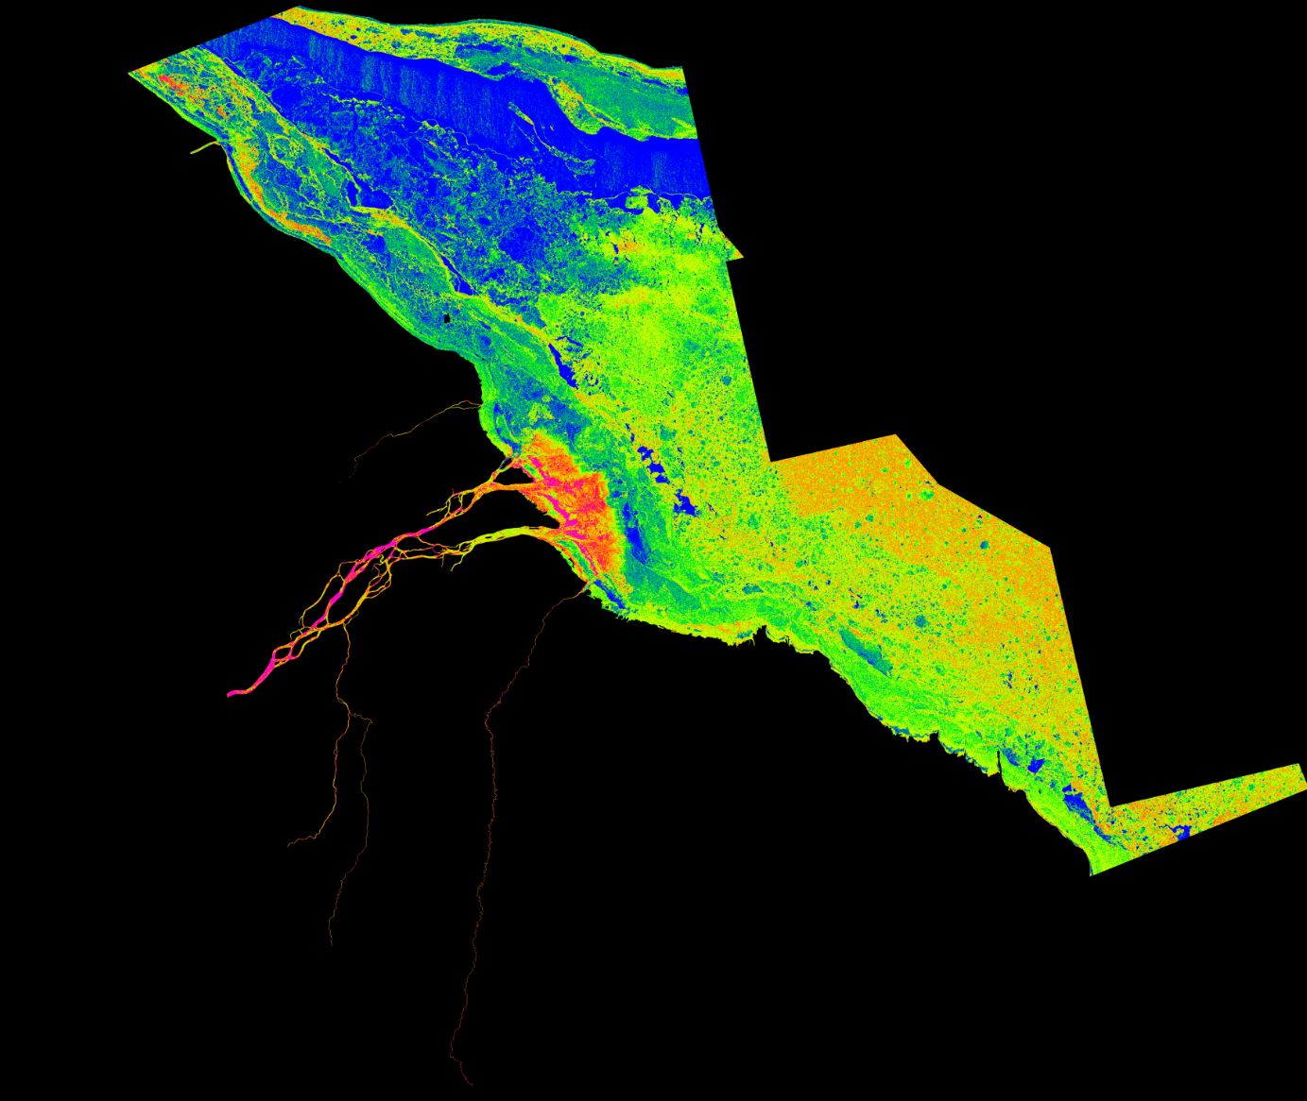

### KMZ File

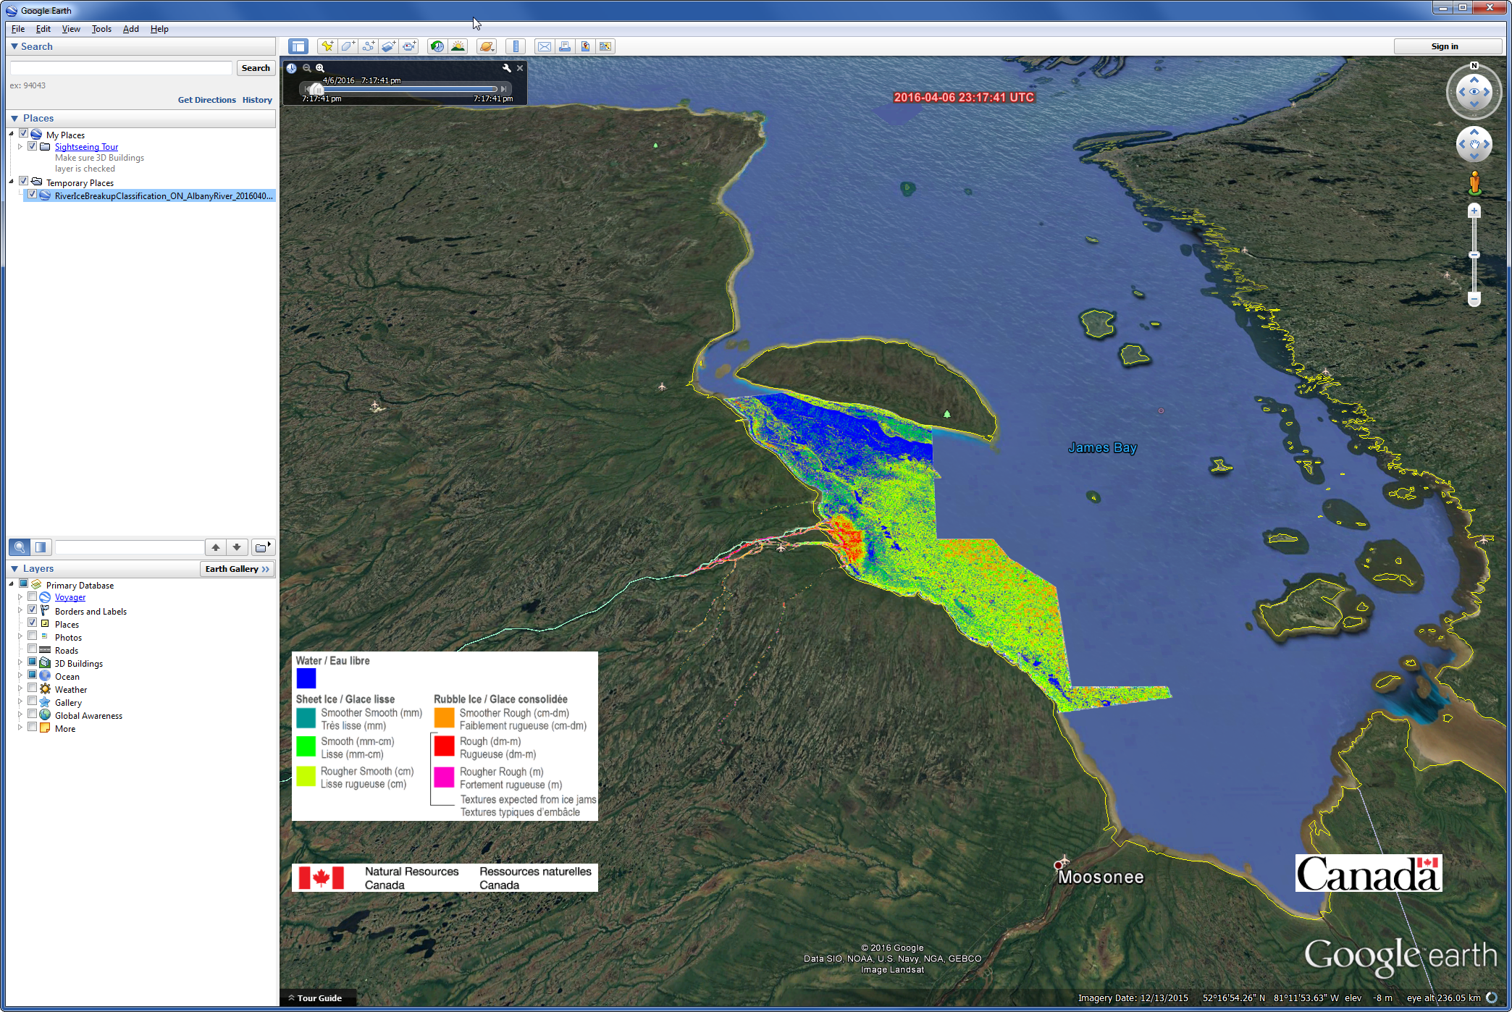

### Map

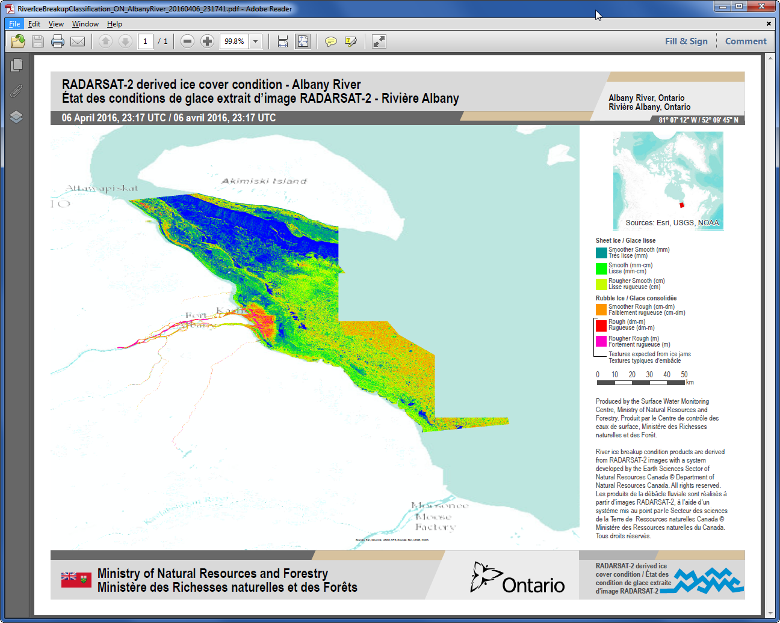

# Appendix A: Database Administration – Firefox SQLite Manger Add-on

There are a number of database administration tools available for managing and accessing SQLite databases. Opinions on the various tools can be found here:

<http://stackoverflow.com/questions/505220/recommendation-for-sqlite-db-manager-application>

While any such tool will likely perform adequately, NRCan has had success using the Firefox **SQLite Manager** add-on, so that tool is described in this Appendix. It allows one to perform basic tasks like creating, altering, populating, examining and querying SQLite databases and tables.

## Installing Firefox SQLite Manager

Open a Firefox web browser. Search for and add **SQLite Manager** through the **Tools->Add-ons** menu. Once installed, open a Firefox browser, then select the **Tools->SQLite Manager** menu to start it.

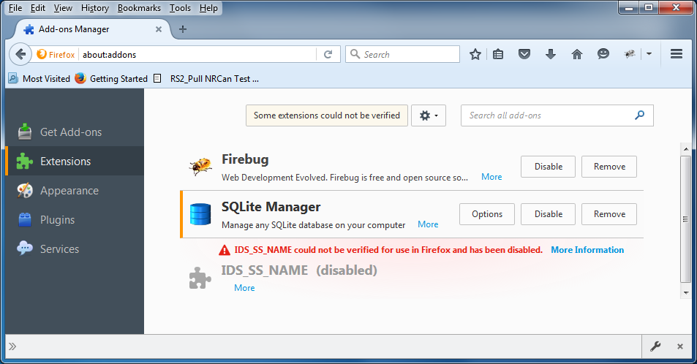

## Examine Database Tables

Start the **SQLite Manager** add-on through the **Tools->SQLite Manager** menu of a Firefox browser:

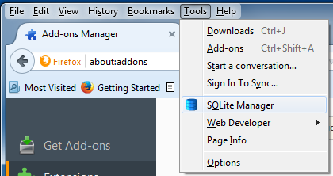

From **SQLite Manager**, select the **Database->Connect Database** menu option and in the windows that opens, navigate to where the database file was installed:

**C:\EGS\applications\db\egs_db.db**

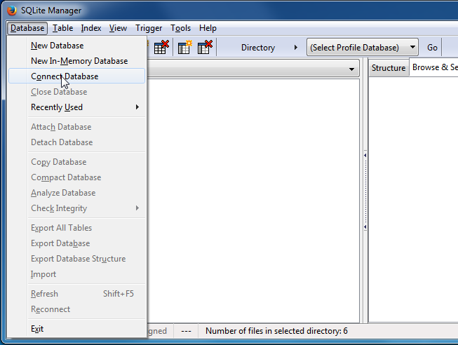

Change the file filter from  to  or you won’t see the file with the “**.db**” extension.

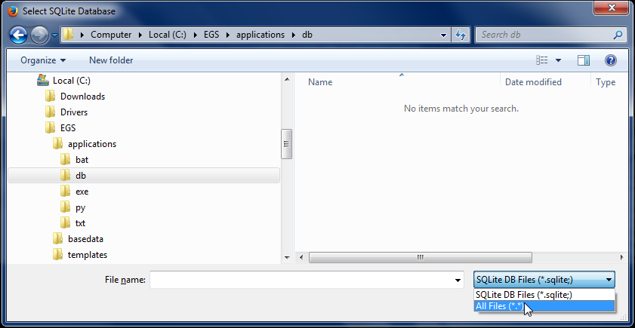

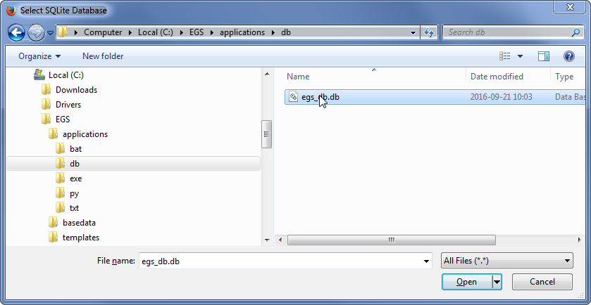

The database will open at the first table in the list.

